For the first example of the holy trinity and how it relates to humanities, I’ve chosen The Holy Bible: New International Version. In the Book of Luke Chapter 1 verse 35 it states, “The angel answered, The Holy Spirit will come on you, and the power of the Most High will overshadow you. So the holy one to be born will be called the Son of God.” (Zondervan). This is one of the multiple references in the Bible that states the holy trinity. I find this literary piece an excellent reference since the book is about the father, son and holy spirit as one and as three separate entities at the same time giving it depth.

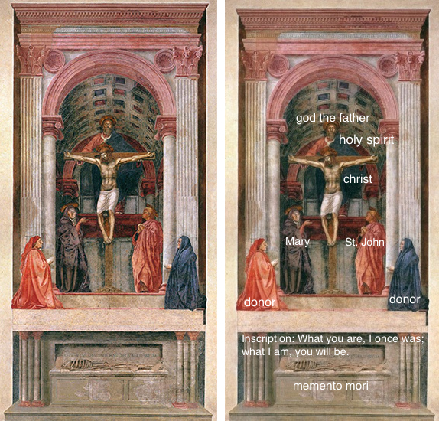
The second example of the holy trinity is a painting that was created by Masaccio in 1427and is located in Santa Maria Novella, Florence. Masaccio used linear perspective in this painting, which this is the first time it was used in the renaissance era. This abstract of the Father, Masaccio depicted him as a human which is different from most according to Dr. Zucker and Dr. Harris, “God was often represented by a hand” (Zucker and Harris, 2019). I found this painting being an accurate depiction of the holy trinity since it shows each entity separately as God, Jesus on the holy cross and the holy spirit draped over the Fathers shoulder.
My third humanity for the holy trinity is the religion of Christianity. The very center of Christianity is the “ultimate foundation in the special religious experience of the Christians” (Stefon and Spence, 2019). As explained through this article God is the history of salvation, Jesus was the embodiment that experienced life with the people and the holy spirit was the thought of creation in life. In the 1520’s roman catholic priests came to North America, and “by 1595 there was serious missionary work in Florida” (Encyclopedia, 2019). Therefore, Christianity was being created into what has become the Religion we have today.
References:
The Holy Bible: New International Version. Zondervan, 1984. November 28, 2019
Dr. Steven Zucker and Dr. Beth Harris, "Masaccio, Holy Trinity," in Smarthistory, October 10, 2019, accessed November 28, 2019, https://smarthistory.org/masaccio-holy-trinity/.
Matt Stefon and Sidney Spence, “The Holy Trinity, The basis for the doctrine of the Trinity” Encyclopedia Britannica accessed November 30, 2019, https://www.britannica.com/topic/Christianity/The-Holy-Trinity
"Christianity: Christianity in North America ." Encyclopedia of Religion . . Encyclopedia.com. 30 Nov. 2019 <https://www.encyclopedia.com>.

